Nico Flota Sanchez
CS152: Computational Thinking: Science
December 8, 2023

FINAL PROJECT:
“Simulating Galaxy Mergers”

ABSTRACT & BACKGROUND:
For my final project I created a Graphic User Interface with Zelle Graphics to create a program that simulates galaxy mergers in 2D. Inspired by previous work on this field, namely Verkade’s Python adaptation of Mihos’ “GalCrash” application in Java, I attempted to adapt Verkade’s version of GalCrash using Zelle instead of PyQt. GalCrash simulates both major and minor galaxy mergers, generating stars in a galaxy formation and advancing these through time to observe how the galaxy merge together. Given the big scope of this project and the complicated physics it involves, I was not able to make finish this project within the deadline, but I did learn how to create GUIs from scratch, and I managed to generate the two galaxy’s initial states given different slews and inclinations for the galaxy morphology and the number of stars in each galaxy.

DESIGN SKETCH/IMAGE:
- Provide a brief description of the specific programming processes, concepts, and/or approaches to your potential employer so they can quickly understand and be persuaded of your programming skills based on the key components of your work.

    - Object-Oriented programming
For this project, I wrote two Python files. The first one, “astro_objects.py”, contains several objects classes that help define the attributes and methods of classes. I made use of inheritance classes by creating a parent Spiral Galaxy class and a child Star class that inherits the attributes and methods of the Galaxy class so that it can use it to initialize stars inside the galaxies. This form of coding is called object-oriented programming, which allows us to import the classes into a different module and create objects from those classes as needed.

    - Creating a GUI:
Other classes included in the astro_objects file are entry boxes and buttons in Zelle, which I used to build a Graphic User Interface. GUIs are used to present information to the user and to allow the user to interact with graphic objects to guide how the program is run. In my case, I created the entry boxes so that the user could enter their desire values for certain parameters of the star and galaxy classes. Additionally, buttons help control when to start, pause, or exit the simulation.

    - Zelle graphics for animations
Zelle Graphics is module that allows us to create a window, draw shapes, and then move the shapes in the window to create animations. Thus, the file “main.py” creates a Zelle graphics window in which to draw the GUI to begin simulations by drawing the necessary objects (defined in astro_objects.py) onto the window. It also controls the flow of information and directs the actions of the program in a more procedural manner.

- THEORY: Explain the scientific processes, datasets, and concepts that you have embedded into your process.
    - Galaxies:
Galaxy mergers are a type of galaxy interactions where the density and morphology of two galaxies change when they approach each other. There are minor mergers, where two galaxies have a large mass ratio (such as 8:1, where one galaxy is 8 times more massive than the other), which do not destroy the morphology of the primary galaxy. There are also major mergers (mass ratios of 1:1), which destroys the initial morphologies of both galaxies, and tends to result in an elliptical galaxy with little internal motion.
When looking at galaxy mergers and other types of galaxy interactions, it is important to consider dynamical friction. This phenomenon is a pseudo-friction force that describes galaxies moving through clusters, where galaxies will experience a drag force due to gravitational interaction with nearby objects. Due to the simplicity of the simulation in this project, I did not calculate it fully, but I followed the steps in Verkade’s paper to approximate it through the Chandrasekhar formula, which states that galaxies should feel a frictional force due to dynamical friction proportional to the mass of the object times the density of the background sea divided by the velocity of the object squared (Mihos et al., 1999). The formula is given in Eq. 1, and a modified version of it (the one used in the code) is given in Eq. 2, where G = 1 and $lnΛ=3.0$.
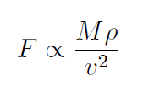 Eq. (1)
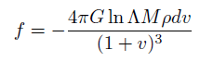 Eq. (2)

For this type of simulation, we also need to calculate the acceleration of the whole by using Newton’s law of universal gravitation (Eq. 3) and the gravitational potential energy formula (Eq. 4). Doing this, we are treating our galaxies as if they have fixed shapes, but in reality the shape of the galaxy is constantly changing as it interacts gravitationally with the other galaxy. We would need to calculate all the gravitational forces between all the stars and dark matter that make up galaxies, which is computationally beyond the capabilities of this simple model. But using the Chandrasekhar dynamical friction approximation, we can observe galaxy mergers in a way that better approaches reality despite not accounting for individual gravitational forces inside galaxies.
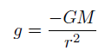 Eq. (3)
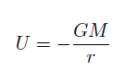 Eq. (4)

The interior mass of the galaxy is calculated depending on r (radius of the disk). If r < rhalo (where rhalo = radius of the dark matter halo), then the companion galaxy is confined within the dark matter halo of the main galaxy, and so the interior mass is calculated with Eq. 5, where $v_{H}$ is the velocity of the dark matter halo, $a_{H}$ is its acceleration, and r is the distance between the two galaxies. Otherwise, the interior mass is simply the mass of the galaxy, since the companion galaxy is not close enough to significantly impact the interior mass of the main galaxy.
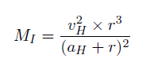 Eq. (5)
    - Stars:
For stars inside the galaxies, we first need to generate stars in the shape of a galaxy. We include calculations of different morphologies of galaxies depending on slew and inclination from our point of view as entered by the user, so we need to be able to convert x, y coordinates to spherical coordinates. To accomplish this, we use the conversions in Eqs. 6-8.

Eq. (6)
Eq. (7)
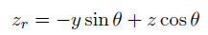 Eq. (8)

We also give stars an escape velocity from their galaxies using Eq. 9, where G = 1 and ignoring the factor of 2 usually present in the escape velocity formula. We then get the x, y-components of the escape velocity using Eq. 10-11, and assign its z-component to zero.
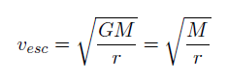 Eq. (9)
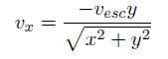 Eq. (10)
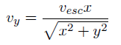 Eq. (11)

- Provide a critical evaluation of your design and what you might do differently in the next iteration. This is an analysis of your own solution and its rationale, methods, and implications.
In the next iteration I would probably use PyQt instead of Zelle. While Zelle is a powerful animation tool, it proved too imprecise for a simulation like this. I also don’t know what better ways to build in entry boxes and buttons are, since I only learned to do them for this project and they were not ideal (like the fact that entry boxes are drawn in succession instead of all at once).
Naturally, the big thing I would like to improve is to actually get a simulation going. I will continue to work this as a personal project and hopefully get some animated results.

- Provide an example(s) of how you have written concise, precise, easy to read code and comments so that it can be easily maintained using good coding style and organization.
One of the clearest examples of clear coding is the main function from main.py, show below. It is the function that controls the flow of information. First, it builds the Zelle window, and then it creates the “scene” by adding lines separating windows, text for instructions and labels, and by creating entry boxes. It then saves the data entered into the entry boxes, creates buttons for the GUI, and once the start button is pressed it uses the the data entered into the boxes as parameters for the Simulate class from the astro_objects module. If the program were running as intended, it would then loop through the update method from the simulation class with a certain time step so that it is visible to the user, updating the window to reflect changes. Then, if the user presses the pause button, the while loop is broken. If the user presses the exit button, the program shuts down.
I liked building this flow because it relies heavily on other modules and functions while still making the general steps understandable. I also skipped lines to create blocks of related code, and I added comments to give insight into what the program is doing.
def main():
"""Main"""
# create a graphics window
win = GraphWin("Galaxy Merger", 1300, 750, False)
win.setBackground("black")

#create the scene
buildSeparations(win)
buildText(win)
entries = buildEntryBoxes(win) #draws the entry boxes

#get starting parameters from entry boxes
yellowtheta = int(entries[0].get_value()) #companion
yellowphi = int(entries[1].get_value()) #companion
bluetheta = int(entries[2].get_value()) #main gal
bluephi = int(entries[3].get_value()) #main gal
peri = int(entries[4].get_value())
massrat = int(entries[5].get_value())
starnum = int(entries[6].get_value())

#Buttons
start = Button(win, 500, 350, 60, "Start")
pause = Button(win, 500, 380, 60, "Pause")
exit = Button(win, 500, 410, 60, "Exit")

#button actions
if start.button_action(win) == True:

while True:
sim = Simulate(win, yellowtheta, yellowphi, bluetheta, bluephi, peri, massrat, starnum)
#win.getMouse()
#sim.update_plot(0.04)
#time.sleep(0.04) # have the animation go at the same speed
win.update()

"""if pause.button_action(win) == True:
break #interrups the while loop""" #lacks functionality without an animation

if exit.button_action(win) == True:
break #closes the program by ending the loop

"""if pause.button_action(win) == True:
#win.close() #exits the program"""

win.close()

- Provide plots, graphs, visualizations, screenshots and/or video links that demonstrate key parts or features of your project with descriptions of their significance.
While I was not able to get the galaxies to move in the simulation, I was able to get all the controls working. These are some of the variations the user can make to the galaxies:
To see how the program runs, watch the video “Generating gals.mp4”.

    - Changing galaxy sizes through the mass ratio parameter:
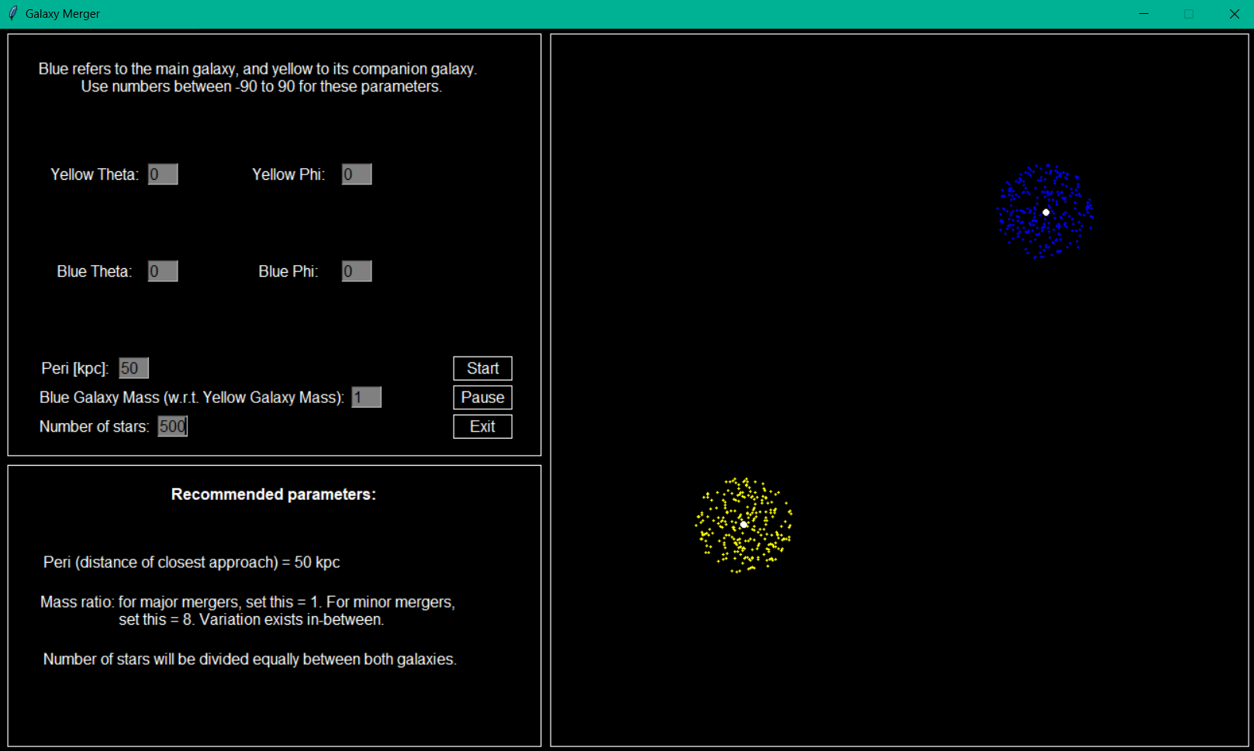
Galaxy mass and size are related, so when the user changes the mass-ratio parameter, they will alter the shape of the main (blue) galaxy. Figs. 1 and 2 show this variation by showing the extreme values.

Figure 1: Shows two spiral galaxies as viewed head-on (0 degree angle) of equal masses (mass ratio = 1:1).
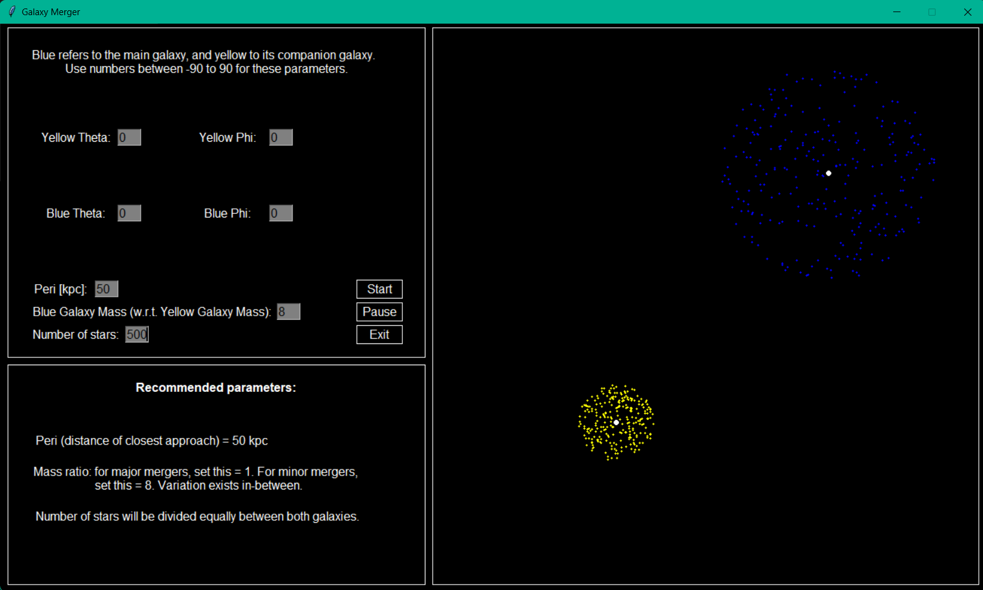
Figure 2: Shows two spiral galaxies as viewed head-on (0 degree angle) of unequal masses (mass ratio = 8:1).

    - Changing the slew and inclination of galaxies:
The slew (theta) and inclination (phi) greatly change galaxy morphology, as soon in Figs. 3-4.
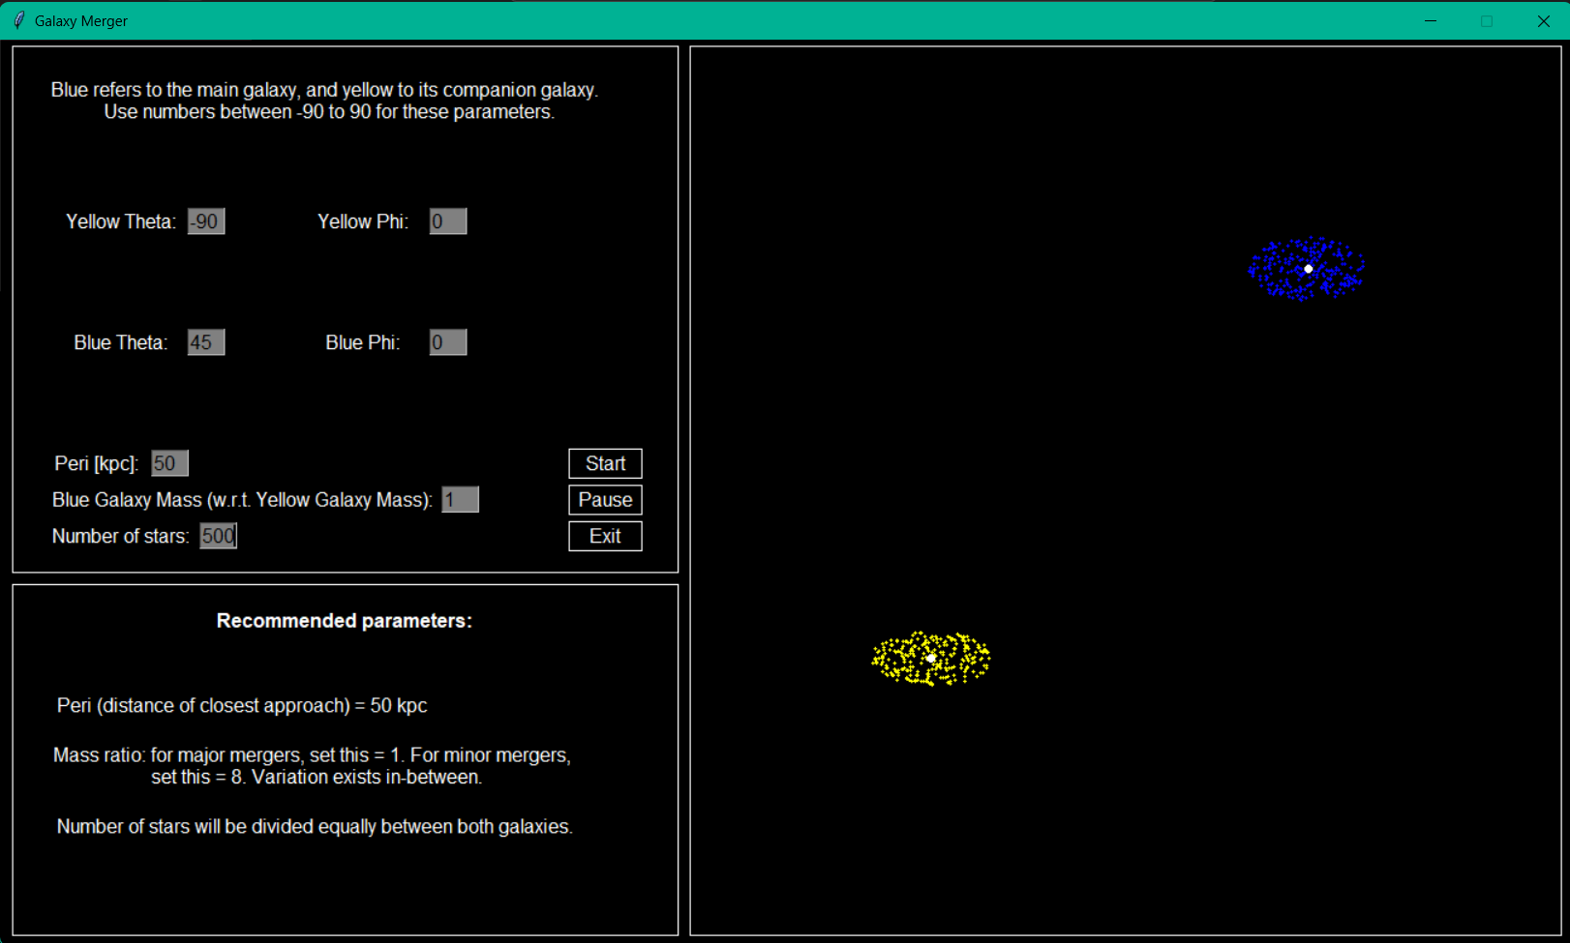
Fig. 3: Galaxies of equal mass while only altering the theta parameter (slew).

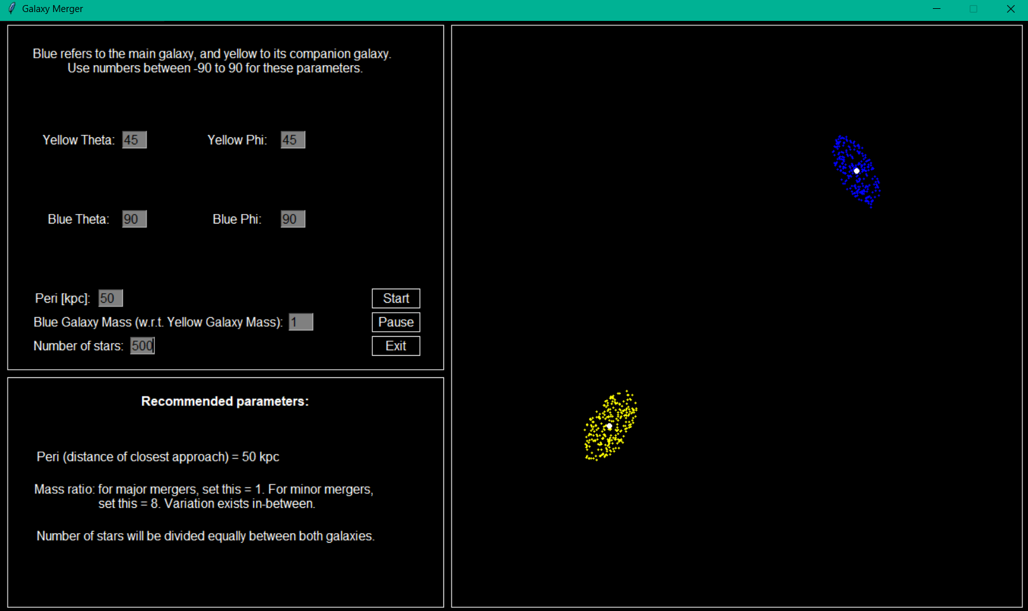
Fig. 4: Galaxies of equal mass while altering the theta parameter (slew) and the phi parameter (inclination).

    - Changing the number of stars in the galaxies:
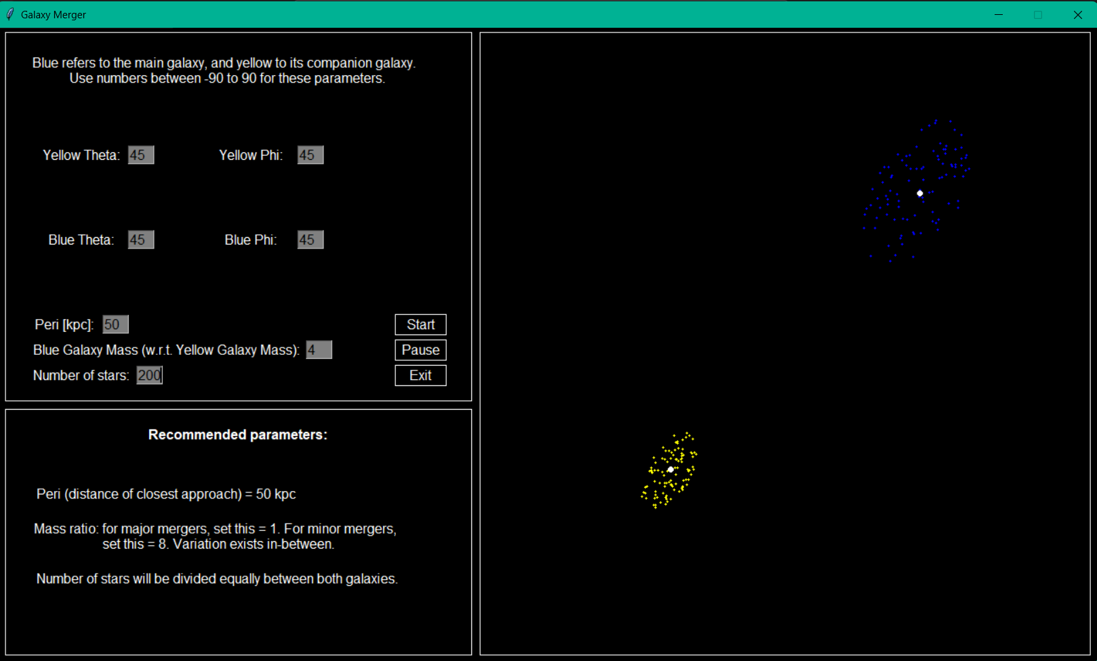
In this simulation, the number of stars is equally distributed between both galaxies, but the number can be altered, as shown in Figs. 5-6.

Fig. 5: Galaxies of mass ratio 4:1 (for presentation), with the same slew and inclination and a number of stars = 200.

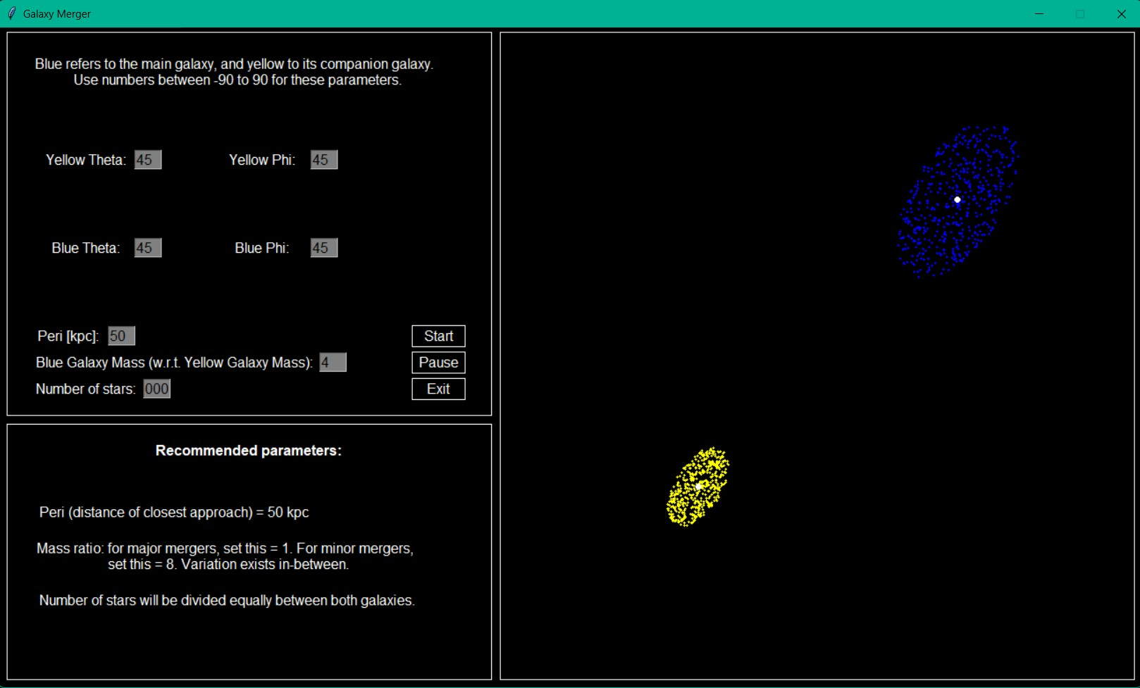
Fig. 6: Galaxies of mass ratio 4:1 (for presentation), with the same slew and inclination and a number of stars = 1000.

- Identify any potential biases or limitations in the dataset(s) or solutions/models and what might be done to safeguard against any harm or negative impact of the analysis.
This type of simulation has many scientific limitations, as mentioned in the theory section. Precise galaxy merger simulations require supercomputers to compute all of the individual gravitational forces inside a galaxy, which gets further complicated during the actual merging process. Additionally, this model is in 2D, where real mergers would appear in 3D space, and our calculation of the dynamical friction is only an approximation. Additionally, this model excludes gravitational interactions with other bodies in space. However, if it worked, this would still be a useful model to learn about galaxy mergers.

- Provide sources that you relied on and properly cite your sources of consultation or inspiration for this project (e.g. peer or expert consultation, images found on the internet, research publications, websites, tools, etc.).
- References:
    - Verkade T. Rijksuniversiteit Groningen Simulating Galaxy Collisions in Python for Astronomy Education. (2020). https://fse.studenttheses.ub.rug.nl/22594/1/bAST_2020_VerkadeT.pdf
    - My notes from AS342: “Galaxies and Cosmology” with Professor Dale Kocevski.

PERSONAL REFLECTION:
Did I complicate myself too much? Yes. Yes, I did. However, this was a fun project, and I feel like I learned a lot from it. First of all, I was surprised to find a paper that was understandable enough for me to follow, both as a computer science and an astrophysics student. I did not need to do something as complicated as this type of simulation with so many moving parts (literally), but writing a simple ballistic motion project did not seem as interesting to me. This project taught me that I can work on a computer science project independently, which is not something I expected.

